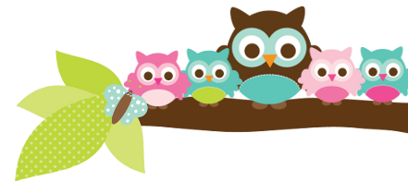
Young 5s and Kindergarten October 16, 2017
What we’re learning!
Phonics
Whole class: This week, we’ll focus on the letter G and sort pictures that begin with the /g/sound and sort uppercase G and lowercase g as well. We will also practice identifying, spelling, and reading our sight words.
Kindergarten: Students will continue to practice identifying, sorting, reading, and tracing words in sentences.
Y5: Students will sort lowercase letters and distinguish between letters and words.

Reading: Our unit this week is on “Transportation in My Neighborhood” by Shelly Lyons. We will make connections to the types of transportation we use. Our vocabulary words are: traffic, crawl, wind, island, and neighborhood.

Handwriting: This week, we’ll practice tracing and writing letters M and N, and our names.

Writing
We’re making progress in writing the sounds we hear in our drawings! This week, we’ll draw and label a picture of the types of transportation we use in our daily lives.

Math
Kindergarten: We will continue to learn about addition, sort objects based on different attributes, and identify circles in our environment.
Y5: Students will review the “one more” pattern of sequential numbers and sort pictures by size and shape.

Science
Kindergarten: This week, we’ll learn how our beta fish would survive in the wild.
Y5: We will begin our unit on “Plants in the Neighborhood” and learn how to identify different types of trees in the environment.

Social Studies: We’ll make a poster on what bullying is and how to handle it.
Kindergarten: We’ll list ways on how to be responsible in school and at home.
Young 5s: We will learn to politely ask for what we need and want using the Second Steps Curriculum.

Important Dates
- Early Dismissal at 1:29pm on Wednesday, October 25.
- Field Trip Friday, October 27 9:45am-12:30pm.
- Parent/Teacher Conferences are from 4:20-7:40pm on Tuesday, October 24, Thursday November 2, and Monday November 6.

Tips/Strategies
*I highly recommend that your child spends at least 10-15 minutes a night reading with you. Ask your child to identify letters and sight words on each page. This will help them become a strong reader.
*I also suggest that you practice counting 1-30 with your child and asking them to identify letters, words, numbers, and shapes in the world around them.
- If you have any questions or concerns, please contact me: vansteel@aaps.k12.mi.us.

Sight words to review:
- and
- go
*We’ll practice identifying, sorting, reading, and writing these words as well as making them with magnetic letters.

Owl Aboard!
Ms. Van’s Newsletter

