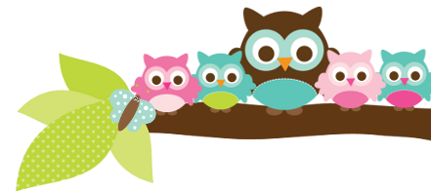
Young 5s and Kindergarten November 6, 2017
What we’re learning!
Phonics
Whole class: This week, we’ll focus on the letter J and sort pictures that begin with J’s sound and sort uppercase J and lowercase j as well. We will also practice identifying, spelling, and reading our sight words.
Kindergarten: Students will continue to practice hearing the beginning sounds in words and matching upper and lowercase letters
Y5: Students will practice identifying upper and lowercase letters as well. We’ll also practice identifying letters in our names.

Reading: Our unit this week is on “The Three Billy Goats Gruff.” We will practice retelling the beginning, middle, and end of the story as well as sequencing the events using pictures. Our vocabulary words are: valley, fine, rushing, roared, and trampled.

Handwriting: This week, we’ll practice tracing and writing letters S and T and our names.
Writing
This week, we’ll learn how it’s alright to make mistakes in our writing and practice stretching out words using our personal alphabet charts. Students really enjoy writing and sharing their work with the class!

Math
Kindergarten: We’ll practice making representations of numbers in our number booklets, sort long and short items, and solve simple story problems.
Y5: Students will practice sorting long and short items as well. We’ll also review positional words and use them to describe an object’s location.

Science
Kindergarten: This week, students will begin their Project Lead the Way (PLTW) Unit on Exploring Design
Y5: We’ll also learn about different types of trees.
Social Studies:
Kindergarten: We’ll practice using positional words to describe our homes and playground and make labeled drawings of them. Young 5s: We will review the importance of being a good friend.
Important Dates
- Parent/Teacher Conferences are from 4:20-7:40pm on Monday, November 6.
- Report Cards go home Nov. 21
- Thanksgiving Break: November 22-24, 2017
- PizzaHut Book It calendars are due Thursday, November 30.

Tips/Strategies
*I highly recommend that your child spends at least 10-15 minutes a night reading with you. Ask your child to identify letters and sight words on each page. This will help them become a strong reader.
*I also suggest that you practice counting 1-50 with your child and asking them to identify letters, words, numbers, and shapes in the world around them.
- If you have any questions or concerns, please contact me: vansteel@aaps.k12.mi.us.

Sight words to review:
- little
- is
- see
*We’ll practice identifying, sorting, reading, and writing these words as well as making them with magnetic letters.

Owl Aboard!
Ms. Van’s Newsletter

