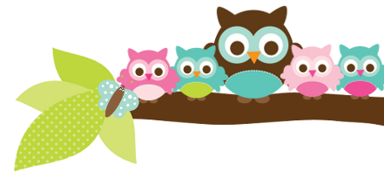
Young 5s and Kindergarten May 7, 2018
What we’re learning!
Phonics
Whole class: This week, we’ll focus on identifying, reading, and writing words with the pl- blend.
Kindergarten: Students will identify, read, and write compound words.
Y5: Students will continue to identify words that have the same beginning sounds and put words in alphabetical order.

Reading: This week, we’ll begin our unit on plants. We’ll practice gathering facts and making connections. Our vocabulary words are: soil, seedling, pollination, and germination.

Handwriting: This week, we’ll focus on tracing and writing uppercase and lowercase letters.
Writing: Last week, the class did a great job researching and writing facts about frogs. This week, we’ll research plants and write facts about how plants grow.

Math
Kindergarten: This week, we’ll continue to practice counting to 100 from numbers other than 1. Students will also practice solving subtraction problems and finding combinations of numbers that add up to 10.
Y5: Students will count on to 50 from a number other than 1, practice identifying numbers 1-20 out of order, and solve simple addition and subtraction stories.

Science:
Kindergarten: Students will continue their Project Lead the Way (PLTW) Science Unit on Structure and Design with our PLTW teacher Ms. Schemanske.
Y5: Students really enjoyed planting grass seeds last week! This week, we’ll learn about leaves that people eat, such as spinach and lettuce.

Social Studies:
Kindergarten: Students will finish writing about goods that are made from our Earth’s trees and water.
Young 5s: We will review fair ways to play.
Important Dates
- Tuesday, 5/8 : No school
- Friday, 5/11: 5th Grade Camp Fundraiser Romulus Athletic Center 5-10 p.m..
- Saturday, 5/12: Washtenaw Elementary Science Olympiad at Pioneer High School
- Monday 5/7-Friday 5/11: Teacher Appreciation Week

- The Fifth Grade Concert has been postponed to 5/29.

Tips/Strategies
*I highly recommend that your child spends at least 10-15 minutes a night reading with you. Ask your child to identify letters and sight words on each page. This will help them become a strong reader.
*I also suggest that you practice counting 1-50 with your child and asking them to identify letters, words, numbers, and shapes in the world around them.
- If you have any questions or concerns, please contact me: vansteel@aaps.k12.mi.us.

Sight words we’ll review
- here
- four
- down

*We’ll practice identifying, sorting, reading, and writing these words as well as making them with magnetic letters.

Owl Aboard!
Ms. Van’s Newsletter

