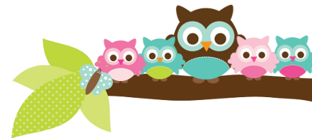
Young 5s and Kindergarten May 29, 2018
What we’re learning!
Phonics
Whole class: This week, we’ll continue to practice identifying, reading, and writing words with the ch- digraph.
Kindergarten: Students will continue to practice putting words in alphabetical order and sort words based on their word families.
Y5: Students will sort words by ending sounds and identify the onset and rhyme in words.

Reading: This week, we’ll begin our unit on friendship and read “Enemy Pie” and “The Sandwich Swap”. We’ll practice identifying the problem and solution in the story. Our vocabulary words are: enemy, recipe, squinted, surprised, and mumbled.

Handwriting: We’ll focus on tracing and writing sight words.
Writing: This week, we’ll begin to write detailed observations of plants in our school garden. We’ll also practice editing and revising sentences.

Math
Kindergarten: This week, we’ll practice adding and subtracting within 10 using different strategies, such as our fingers, a number line, or a drawing.
Y5: Students will continue to practice solving number stories, and making patterns. We’ll also practice identifying 3-D shapes.

Science:
Kindergarten: Last week, students really enjoyed exploring dirt, sand, and water in outdoor stations! This week, we’ll further explore sand to determine what sand is made of.
Y5: This week, we’ll learn the difference between fruits and vegetables.

Social Studies:
Kindergarten and Young 5s: This week, we’ll focus how we take responsibility for certain tasks at home and at school.

Important Dates
- Monday, May 28 - No School (Memorial Day)
- Friday, June 1-Field Day (The Y5/K-2nd Grade session is from 9-11:30 a.m.).
- Carpenter’s Carnival- June 8 at 6:30 p.m..

Tips/Strategies
*I highly recommend that your child spends at least 10-15 minutes a night reading with you. Ask your child to identify letters and sight words on each page. This will help them become a strong reader.
*I also suggest that you practice counting 1-50 with your child and asking them to identify letters, words, numbers, and shapes in the world around them.
- If you have any questions or concerns, please contact me: vansteel@aaps.k12.mi.us.

Sight words we’ll review
- they
- there
- this

*We’ll practice identifying, sorting, reading, and writing these words as well as making them with magnetic letters.

Owl Aboard!
Ms. Van’s Newsletter

