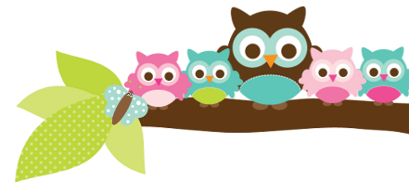
Young 5s and Kindergarten May 14, 2018
What we’re learning!
Phonics
Whole class: This week, we’ll continue to practice identifying, reading, and writing words with the pl- blend.
Kindergarten: Students will practice isolating blends and word families within words.
Y5: Students will practice sounding out words and identifying words that have the same beginning and ending sounds.

Reading: This week, we’ll begin our unit on butterflies. We’ll practice gathering facts and identifying the life cycle of a butterfly. Our vocabulary words are: nectar, chrysalis, migration, instinct, and generation.

Handwriting: This week, we’ll focus on tracing and writing uppercase and lowercase letters.
Writing: This week, we’ll learn how to use our 5 senses to elaborate on our topics.

Math
Kindergarten: This week, we’ll focus on identifying combinations of 10 (1 +9, 8 +2, etc.), using different strategies to solve addition and subtraction problems, and ordering numbers from least to greatest.
Y5: Students will identify combinations of 10 and match teen numbers to quantities. Students will also play a game in which they turn over two number cards and identify which number is higher and which is lower.

Science:
Kindergarten: Students will continue their Project Lead the Way (PLTW) Science Unit on Structure and Design with our PLTW teacher Ms. Schemanske.
Y5: This week, we’ll learn about the important role roots play in the growth of plants.

Social Studies:
Kindergarten: We’ll begin our last unit, “How Do I Get Along with Others?.” Students will review how we can’t always do what we want because it can lead to unsafe or unfair situations.
Young 5s: We will review how to brainstorm solutions to problems together.
Important Dates
- Friday, May 18: Carpenter Dance-details coming soon!
- Wednesday, May 23: Early Release @ 1:29 p.m..
- Monday, May 28 (Memorial Day)- No School

Tips/Strategies
*I highly recommend that your child spends at least 10-15 minutes a night reading with you. Ask your child to identify letters and sight words on each page. This will help them become a strong reader.
*I also suggest that you practice counting 1-50 with your child and asking them to identify letters, words, numbers, and shapes in the world around them.
- If you have any questions or concerns, please contact me: vansteel@aaps.k12.mi.us.

Sight words we’ll review
- here
- funny
- who

*We’ll practice identifying, sorting, reading, and writing these words as well as making them with magnetic letters.

Owl Aboard!
Ms. Van’s Newsletter

