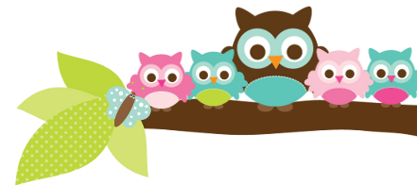
Young 5s and Kindergarten June 4, 2018
What we’re learning!
Phonics
Whole class: This week, we’ll continue to practice identifying, reading, and writing words with the th- digraph at the beginning and end of words.
Kindergarten: Students will sort words by initial sounds. We’ll also practice identifying and writing the beginning, middle, and ending sounds of words.
Y5: Students will practice putting words in alphabetical order and sorting sight words.

Reading: This week, we’ll begin our unit on tigers. We’ll practice identifying key facts and make connections. Our vocabulary words are: den, prey, territory, tigress, and carnivore.

Handwriting: We’ll focus on tracing and writing our names. Students will practice only capitalizing the first letter in their name.
Writing: This week, we’ll connect writing to our reading unit on tigers. Students will write 2-3 interesting facts about tigers and draw pictures with detailed labels.

Math
Kindergarten: This week, we’ll use our backpacks to practice measuring height and weight and to determine the area and capacity of an object. We’ll also continue to practice solving addition stories using the counting on and number line methods.
Y5: Students will practice identifying and extending patterns. We’ll also practice solving addition and subtraction stories.

Science:
Kindergarten: Last week, we furthered explored dirt to determine what dirt is made of. This week, we’ll focus on what sand is.
Y5: This week, we’ll learn about grains and how they are a part of our diet.

Social Studies:
Kindergarten and Young 5s: This week, we’ll focus on how to make fair decisions.

Important Dates
- Friday, June 8: Carpenter’s Carnival @ 6:30 p.m..
- Friday, June 15: Last Day of School. Early Release at 11: 35 a.m..

Tips/Strategies
*I highly recommend that your child spends at least 10-15 minutes a night reading with you. Ask your child to identify letters and sight words on each page. This will help them become a strong reader.
*I also suggest that you practice counting 1-50 with your child and asking them to identify letters, words, numbers, and shapes in the world around them.
- If you have any questions or concerns, please contact me: vansteel@aaps.k12.mi.us.

Sight words we’ll review
- come
- where
- away

*We’ll practice identifying, sorting, reading, and writing these words as well as making them with magnetic letters.

Owl Aboard!
Ms. Van’s Newsletter

