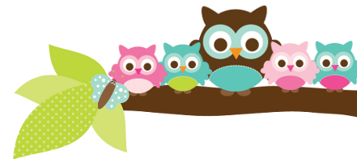
Young 5s and Kindergarten June 11, 2018
What we’re learning!
Phonics
Whole class: This week, we’ll continue to practice identifying, reading, and writing words with the bl, cl, and sl blend.
Kindergarten: Students will match rhyming words and identifying and sort words of the same word families.
Y5: Students will continue to practice putting words in alphabetical order and sorting sight words.

Reading: This week, we’ll read “The Adventures of Rainbow Fish” and practice retelling the beginning, middle, and end of the story as well as making inferences.

Handwriting: We’ll focus on tracing and writing upper and lowercase letters and numbers.

Writing: Last week, our students did a great job writing interesting facts about tigers! This week, we’ll write about our favorite event this year and practice editing and revising sentences filled with mistakes.

Math
Kindergarten: Last week, students did a great job completing graphs, solving number stories and measuring the height, weight, and area of backpacks. This week, we’ll determine the capacity of two backpacks and measure time in seconds. Y5: Students will work on solving number problems using number lines and pictures.

Science:
Kindergarten: This week, we’ll further explore water and learn about ocean animals.
Y5: This week, we’ll learn how we can create our own gardens at home.

Social Studies:
Kindergarten and Young 5s: This week, we’ll focus on how to talk through a problem and brainstorm ways to solve it.

Important Dates
- Monday, June 11:
- Bingo for Books 9:15-10am
- Parent Volunteer Appreciation 9-12:00pm
- Family Picnic 12-12:50pm
- Friday, June 15: Last Day of School. Early Release at 11: 35 a.m.. Report Cards are sent home.

Tips/Strategies
*I highly recommend that your child spends at least 10-15 minutes a night reading with you. Ask your child to identify letters and sight words on each page. This will help them become a strong reader.
*I also suggest that you practice counting 1-50 with your child and asking them to identify letters, words, numbers, and shapes in the world around them.
- If you have any questions or concerns, please contact me: vansteel@aaps.k12.mi.us.

Sight words we’ll review
- now
- new
- did

*We’ll practice identifying, sorting, reading, and writing these words as well as making them with magnetic letters.

Owl Aboard!
Ms. Van’s Newsletter

