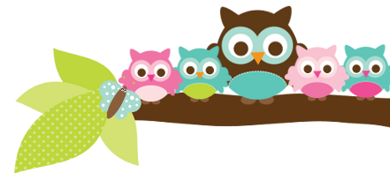
Young 5s and Kindergarten December 4, 2017
What we’re learning!
Phonics
Whole class: This week, we’ll focus on the letter ‘N’ and sort pictures that begin with the /n/ sound. We’ll sort uppercase ‘N’ and lowercase ‘n’ as well. We will also practice identifying, spelling, and reading our sight words.
Kindergarten: Students will practice sorting letters in their name and those not in their name. We will also practice identifying and reading color words.
Y5: Students will practice identifying capital letters and color words. We’ll also review how to clap out syllables in words.

Reading: Our unit this week will focus on “Owl Babies” by Martin Waddell and “Owls” by Laura Marsh. We will practice identifying the parts of owls and listing facts. Our vocabulary words are: camouflage, prey, talons, wingspan, and owlet.

Handwriting: This week, we’ll practice tracing and writing numbers 9-10.
Writing: This week, we’ll continue to practice capitalizing the first word in our sentences and names. We’ll also learn how to add spaces between our words and use color words.

Math
Kindergarten: We’ll review identifying numbers that are greater than or less than another number and practice writing numbers. We’ll also begin Unit 4 on Shapes and practice sorting shapes by attributes.
Y5: We’ll practice matching numbers to quantities, sorting shapes, and identifying teen numbers.

Science
Kindergarten: We will review what students learned about motion, pushes, and pulls from their PLTW unit.
Y5: We’ll continue our unit on Animals in the Neighborhood by learning about owls and cardinals. We’ll also learn what birds eat.

Social Studies:
Kindergarten: We’ll learn how we are in several places at one time (classroom, Carpenter, Ann Arbor, Michigan, United States).
Young 5s: We’ll review fair ways to play with others.
Important Dates
- PizzaHut Book It calendars are due Monday, December 4.
- Winter Greenery Orders due Wednesday, December 6.
- Winter Break: Monday, December 25-January 7.

Tips/Strategies
*I highly recommend that your child spends at least 10-15 minutes a night reading with you. Ask your child to identify letters and sight words on each page. This will help them become a strong reader.
*I also suggest that you practice counting 1-50 with your child and asking them to identify letters, words, numbers, and shapes in the world around them.
- If you have any questions or concerns, please contact me: vansteel@aaps.k12.mi.us.

Sight words to review:
- my
- big
- jump
*We’ll practice identifying, sorting, reading, and writing these words as well as making them with magnetic letters.

Owl Aboard!
Ms. Van’s Newsletter

