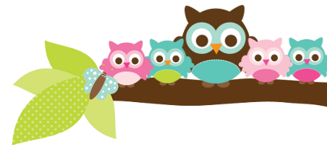
Young 5s and Kindergarten December 18, 2017
What we’re learning!
Phonics
Whole class: This week, we’ll focus on the letter ‘P’ and sort pictures that begin with the /p/ sound. We’ll sort uppercase ‘P’ and lowercase ‘p’ as well.
Kindergarten: Students will practice identifying and sorting the beginning sounds of words and letters in their names.
Y5: Students will practice identifying sight words in sentences and learn how two words can be combined to make compound words.

Reading: Our unit this week will focus on “The Polar Express” by Chris Van Allsburg. We will practice identifying the characters, setting, problem, and solution of the story. Our vocabulary words are: conductor, steam, wilderness, harness, peak, and flicker. * We will also read about the other holidays that are celebrated this month (Hanukkah and Kwanza) for informational purposes.

Handwriting: This week, we’ll practice tracing and writing letters D and E.
Writing: This week, we’ll learn how to write sentences about the past and review the importance of mechanics (punctuation, capitals, spacing).

Math
Kindergarten: We’ll review 2-D shapes by making pattern block designs. Students will continue to review how to identify different representations of teen numbers. We’ll also use cubes to decompose numbers.
Y5: We’ll match teen numbers to quantities, identify 2-D shapes, and use cubes to build numbers.

Science:
Kindergarten: We will review how pushes and pulls can change the direction of an object.
Y5: The class really enjoyed Mr. Szczygiel’s visit last week on how animals migrate or hibernate during the winter. This week, we’ll learn about what habitats are.

Social Studies:
Kindergarten: We’ll begin to learn about our wonderful state of Michigan and how it is part of the United States.
Young 5s: We’ll review how to solve conflicts with friends during playtime.
Important Dates
- Winter Break: Monday, December 25-January 7.
- School resumes on Monday, January 8th.
- PizzaHut Book It calendars are due Tuesday, January 9.

Tips/Strategies
*I highly recommend that your child spends at least 10-15 minutes a night reading with you. Ask your child to identify letters and sight words on each page. This will help them become a strong reader.
*I also suggest that you practice counting 1-50 with your child and asking them to identify letters, words, numbers, and shapes in the world around them.
- If you have any questions or concerns, please contact me: vansteel@aaps.k12.mi.us.

Sight words to review:
- said
- up
- in
*We’ll practice identifying, sorting, reading, and writing these words as well as making them with magnetic letters.

Owl Aboard!
Ms. Van’s Newsletter

