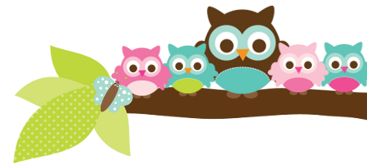
Young 5s and Kindergarten April 30, 2018
What we’re learning!
Phonics
Whole class: This week, we’ll focus on identifying, reading, and writing words with the cl- blend.
Kindergarten: Students will identify and read family words and days of the week in text.
Y5: Students will continue to practice clapping out the syllables in words. We’ll also identify words that have the same beginning and ending sounds.
Reading: This week, we’ll begin our unit on frogs. We’ll practice gathering facts and making connections. Our vocabulary words are: croak, gills, habitat, and poison.

Handwriting: This week, we’ll focus on tracing and writing uppercase and lowercase letters.
Writing: This week, we’ll begin our unit on Informational Writing! We’ll learn how to be great reporters who gather important facts on cats and dogs.

Math
Kindergarten: This week, we’ll begin Unit 8, which focuses on 3-D shapes, counting, and solving number stories. We’ll identify and make 3-D shapes and practice counting on from numbers other than 1 to 100.
Y5: Students will practice identifying 2-D and 3-D shapes in the environment, count on from a number other than 1 to 30, and solve simple addition and subtraction stories.

Science:
Kindergarten: Students will continue their Project Lead the Way (PLTW) Science Unit on Structure and Design with our PLTW teacher Ms. Schemanske.
Y5: We will practice identifying the different parts of plants in our school garden and begin to grow grass seed as well.

Social Studies:
Kindergarten: Students will continue to identify and list goods we receive from the Earth’s resources, such as paper.
Young 5s: We will review how to offer help to friends who need it.
Important Dates
- Tuesday, 5/1-Administrator Day
- No School on Tuesday, 5/8
- Wednesday, 5/9: Fifth Grade Concert 3-3:40pm in MPR
- Monday 5/7-Friday 5/11: Teacher Appreciation Week

Tips/Strategies
*I highly recommend that your child spends at least 10-15 minutes a night reading with you. Ask your child to identify letters and sight words on each page. This will help them become a strong reader.
*I also suggest that you practice counting 1-50 with your child and asking them to identify letters, words, numbers, and shapes in the world around them.
- If you have any questions or concerns, please contact me: vansteel@aaps.k12.mi.us.

Sight words we’ll review
- are
- want
- under

*We’ll practice identifying, sorting, reading, and writing these words as well as making them with magnetic letters.

Owl Aboard!
Ms. Van’s Newsletter

