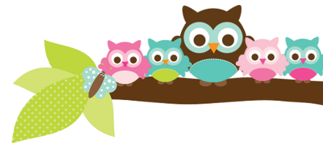
Young 5s and Kindergarten April 2, 2018
What we’re learning!
Phonics
Whole class: This week, we’ll focus on identifying, creating, and reading words in the the –id and –ig families.
Kindergarten: Students will practice identifying the beginning, middle, and ending sounds of words.
Y5: Students will continue to match uppercase and lowercase letters. They will also practice identifying the middle and ending sounds of words.

Reading: This week, we’ll begin our unit on snakes. This week, we’ll practice asking questions while we’re
reading non-fiction books. Our vocabulary words are: molt, hibernate, predators, prey, pupil, and scutes.

Handwriting: This week, we’ll focus on tracing and writing letters W and X.
Writing: We’ll continue our unit on Opinion Writing. This week, we’ll practice writing two reasons to support our opinion on what makes someone a good friend. This will be prepare students for our final Opinion project happening later this month.

Math
Kindergarten: We’ll solve subtraction and addition problems using number sentences (equations). Students will also practice using a number line to solve story problems.
Y5: Students will practice solving take-away (subtraction) and addition number stories that relate to everyday activities. We’ll also create collections that represent specific teen numbers.

Science:
Kindergarten: We’ll review how our body digests food.
Y5: Students will compare the volume of different containers and identify which container has the most and least volume.

Social Studies:
Kindergarten: Students will review how we get our needs and wants met by good and services. Students will differentiate between the two and write a sentence describing a good or service.
Young 5s: Students will practice inviting others to play as well as joining others in play.
Important Dates
- Spring Break: 3/26-3/30.
- School Resumes: 4/2
- Spring Pictures: Tuesday, 4/3 at 9am
- Dr. Swift’s Listen and Learn meeting at Carpenter: 4/4 @ 6-7:30pm

Tips/Strategies
*I highly recommend that your child spends at least 10-15 minutes a night reading with you. Ask your child to identify letters and sight words on each page. This will help them become a strong reader.
*I also suggest that you practice counting 1-50 with your child and asking them to identify letters, words, numbers, and shapes in the world around them.
- If you have any questions or concerns, please contact me: vansteel@aaps.k12.mi.us.

Sight words to review
We’ll continue to focus on these words this week:
- out
- went
- too

*We’ll practice identifying, sorting, reading, and writing these words as well as making them with magnetic letters.

Owl Aboard!
Ms. Van’s Newsletter

