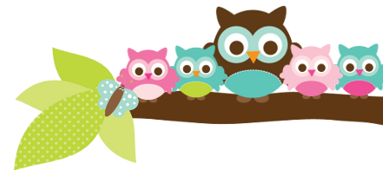
Young 5s and Kindergarten April 23, 2018
What we’re learning!
Phonics
Whole class: This week, we’ll focus on identifying, creating, and reading words in the –ice family. We’ll also practice putting words in alphabetical order.
Kindergarten: Students will identify and sort CVCe (Consonant, Vowel, Consonant, E) words. We’ll also create words by changing the first letter or word family.
Y5: Students will practice clapping out the syllables in words and identify the beginning, middle, and ending sounds in words.
Reading: This week, we’ll begin our unit on horses. We’ll practice asking questions while we read non-fiction books. Our vocabulary words are: breed, herd, mare, shelter, tame, and wild.

Handwriting: This week, we’ll focus on tracing and writing letters Y and Z as well as sight words.
Writing: Last week, students completed their rough drafts, edited them, and finished their final drafts for display! This week, we’ll begin writing facts about horses.

Math
Kindergarten: Students will use dice to solve addition problems and identify 2-D and 3-D shapes by their attributes. We’ll also begin to collect items for the classroom and practice adding as the collection grows.
Y5: Students will practice how to identify and extend different patterns, count by 2’s and 5’s to 100, and how to give ‘food’ in fair shares.

Science:
Kindergarten: Students will begin their Project Lead the Way (PLTW) Science Unit on Structure and Design with our PLTW teacher Ms. Schemanske.
Y5: We will continue our unit on Plants in the Neighborhood by identifying the different parts of a plant.

Social Studies:
Kindergarten: Students will identify the goods we receive from the Earth, such as wood.
Young 5s: We will review how to resolve conflicts between friends.
Important Dates
- Monday, 4/23: Field Day T-Shirt orders are due.
- Thursday, 4/26: Fourth Grade Musical Concert 6:30-7:15pm
- Friday, 4/27: Movie Night

Tips/Strategies
*I highly recommend that your child spends at least 10-15 minutes a night reading with you. Ask your child to identify letters and sight words on each page. This will help them become a strong reader.
*I also suggest that you practice counting 1-50 with your child and asking them to identify letters, words, numbers, and shapes in the world around them.
- If you have any questions or concerns, please contact me: vansteel@aaps.k12.mi.us.

Sight words we’ll continue to review
- will
- now
- have

*We’ll practice identifying, sorting, reading, and writing these words as well as making them with magnetic letters.

Owl Aboard!
Ms. Van’s Newsletter

