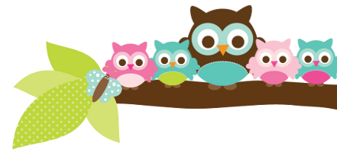
Young 5s and Kindergarten April 16, 2018
What we’re learning!
Phonics
Whole class: This week, we’ll focus on identifying, creating, and reading words in the –ake family. We’ll also practice putting words in alphabetical order.
Kindergarten: Students will ‘correct’ mixed up sentences so that they are correct. We will also work to identify the short vowel sound in the middle of words.
Y5: Students will practice identifying beginning sounds in words and the onset and rime of words from different word families.
Reading: This week, we’ll begin our unit on storms. We’ll practice making connections while we read non-fiction books. Our vocabulary words are: weather, crystal, electricity, and funnel.

Handwriting: This week, we’ll focus on tracing and writing letters Y and Z as well as sight words.
Writing: Last week, we began our final Opinion project. Students did a great job stating their opinions on what makes someone a good friend and giving reasons to support it. This week, we’ll complete our rough drafts, edit them, and then write our final drafts for display!

Math
Kindergarten: Students will create a survey and learn how to represent the data in a bar graph. Students will also practice making estimations and finding combinations of 10.
Y5: Students will learn how to take a survey, graph weather, and how to give ‘food’ in fair shares.

Science:
Kindergarten: We will combine our Reading Unit with Science so students can develop a stronger understanding of storms and how rain affects plants.
Y5: We will begin our unit on Plants in the Neighborhood by identifying plants around our school.

Social Studies:
Kindergarten: Students will learn how to identify and sort good and bad trades.
Young 5s: We will review our anti-bullying policy and how to prevent bullying.
Important Dates
- 4/20: Heritage Festival 5:30-7:00 p.m.. Everyone is welcome to participate as a presenter or to simply attend and enjoy!
- 4/20: Field Day T-Shirt orders are due.

Tips/Strategies
*I highly recommend that your child spends at least 10-15 minutes a night reading with you. Ask your child to identify letters and sight words on each page. This will help them become a strong reader.
*I also suggest that you practice counting 1-50 with your child and asking them to identify letters, words, numbers, and shapes in the world around them.
- If you have any questions or concerns, please contact me: vansteel@aaps.k12.mi.us.

Sight words to review
- will
- now
- have

*We’ll practice identifying, sorting, reading, and writing these words as well as making them with magnetic letters.

Owl Aboard!
Ms. Van’s Newsletter

